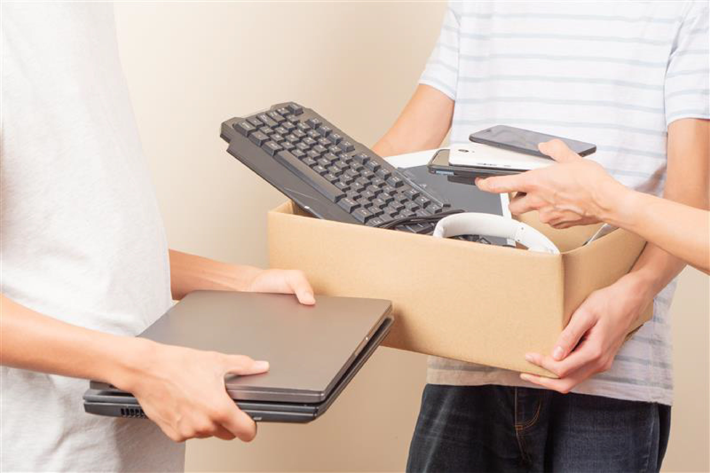
Social Media Content and Image

NAME of SCHOOL
We invite staff, students and family to bring in your old and broken electronics for responsible recycling and help generate funds for our school.

𝗜𝗳 𝗶𝘁 𝗵𝗮𝘀 𝗮 𝗰𝗼𝗿𝗱 𝗼𝗿 𝗿𝘂𝗻𝘀 𝗼𝗻 𝗯𝗮𝘁𝘁𝗲𝗿𝗶𝗲𝘀, 𝗯𝗿𝗶𝗻𝗴 𝗶𝘁 𝗶𝗻!
What can be recycled:
• All electronics (including TVs)
• All appliances (including items with freon or refrigerants)
• Rechargeable batteries
• Miscellaneous scrap metal
All materials are taken to an R2v3-certified recycling facility in Sheboygan, WI for responsible, environmentally sound processing.
Location:
• School to provide details
Dates and Hours:
• School to provide details
Learn more and see a full list of accepted items at: sccwi.gov/Recycling
This program keeps harmful materials out of landfills while turning unused or broken electronics into
a financial benefit for our school.

